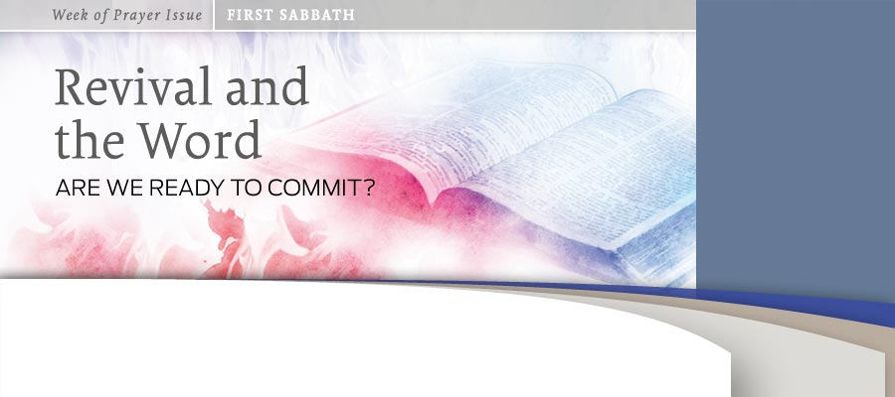
BY Ted N.C. Wilson
As we begin a week of special emphasis on revival and the Word you may wonder why we need more messages on revival. Perhaps you are a Seventh-day Adventist Christian who feels contented to see things continue as they have. A nice church service on a Sabbath morning and a basically moral life may be the essence of what being a Seventh-day Adventist is to you. If this seems to be sufficient for you, then you are missing out on the best part of being a Seventh-day Adventist!
Perhaps the idea of revival is appealing to you. As you look at world events and cultural and social changes you feel that everything is headed for disaster. You may long for a revival, thinking that revival will mean going back to the basics of society—back to the security of a well-ordered time and way of doing things.
Security and order are not appealing to everyone. Perhaps you are interested in a revival to shake things up. You would like to see more power, more action, more miracles, and rapid church growth. Although all these things can and will take place as a result of revival, they are not the heart of revival.
We stand, individually and as a church, poised for a wonderful spiritual experience as we study about revival. While a great experience is a good beginning, true revival must go beyond a brief experience. It must be even more than a new beginning. Revival implies going all the way back to the beginning. “In the beginning was the Word, and the Word was with God, and the Word was God. He was with God in the beginning. Through him all things were made; without him nothing was made that has been made” (John 1:1-3).

The Heart of True Revival
Revival is more than going back to basics or shaking things up. It is more than about power or influence. Revival is about renewing our focus on Jesus. Through Jesus creation took place, and it is only through Jesus that a re-creation or revival can take place. Jesus is, and must be, central to any revival.
Do we need this kind of revival? We are still here. Jesus has not yet come to take us home. We have not yet experienced the promised outpouring of the Holy Spirit that will enable us to finish the task of taking the three angels’ messages to “every nation, and kindred, and tongue, and people” (Rev. 14:6, KJV). We as a church need this revival, but this revival will not come to us corporately without its first being a personal experience.
Do we need revival personally? Each of us can administer the simple self-test by asking ourselves, “Who has the heart? With whom are our thoughts? Of whom do we love to converse? Who has our warmest affections and our best energies? If we are Christ’s our thoughts are with Him, and our sweetest thoughts are of Him. All we have and are is consecrated to Him. We long to bear His image, breathe His spirit, do His will, and please Him in all things.”1
Reviving Relationship
For a revival to begin, we must each focus upon our relationship with Jesus. If we understand that we are saved by grace and are completely dependent on and indebted to a powerful God who has not only created us but redeemed us, we will not opt for a mechanistic, legalistic approach. Our grateful and complete surrender to our Lord will result in a Spirit-filled, dynamic, and vibrant Christian life and witness.
We all need to understand fully where we are in the flow of time and where we are in reference to Jesus’ soon coming. We must remember that the great controversy is raging all around us and often in us, and that the devil wants to derail our spiritual life and connection with Christ to prevent the loud cry of Revelation 14 from being heard around the world.
Knowing Means Sharing
The revival we need is not based on emotionalism or miracles. We want to know Jesus better so we can share Him more. We need the motivation and power of the Holy Spirit for evangelism. We need Jesus to send the promised Spirit as He did to His waiting followers at Pentecost (John 16:7). Our need is perhaps nowhere more pronounced than in the challenge of reaching the big cities. More than half the world’s population is already living in cities, and yet in many cities we barely have a foothold. Remembering the words of the prophet Zechariah, we realize that the Great Commission will be fulfilled, “ ‘Not by might nor by power, but by My Spirit,’ says the Lord of hosts” (Zech. 4:6, NKJV).2
How will we be able to make an impact? New plans and strategies may have their place but what we really need is the miracle-working power of the Word that created all things in the beginning. We need to open ourselves to be God’s agents in bringing the good news of Jesus’ saving victory and soon coming “to every nation, tribe, tongue, and people” (Rev. 14:6).
Experiencing Growth
In order to know Jesus better so that we can share Him better, we need to cultivate a relationship with Jesus and continue to grow in our walk with the Lord. Accepting Jesus is not a one-time experience. It has to be a growing experience. Like the apostle Paul, we have to be willing to die to self daily (1 Cor. 15:31).
The idea of cultivating a relationship with Jesus is not new to us, but because we cannot see Him, we often struggle with really making it work. Any relationship is about communication. Prayer opens our hearts and draws us into an intimate relationship with Jesus. The walls that keep us from this intimate experience with Jesus fall as we plead with God to take them down. All pride, bitterness, complacency, and materialism can be broken through by the Spirit as we spend time with Jesus in prayer.
In our busy lives it is challenging to keep our love for Jesus vibrant, with so many demands on our time and attention. We will have to proactively carve out time to listen to God.
Although God speaks to us through His providential workings and the impressions of the Holy Spirit on our minds, the clearest way God communicates with us is through His Word. As we take the time to study the Word of God we should prayerfully ask the Holy Spirit to be present and remove anything separating us from God.
As Seventh-day Adventists we have been given a wonderful treasure. The Spirit of Prophecy is one of God’s greatest gifts to His end-time remnant people. It is, in Ellen White’s words, the “lesser light” leading to the “greater light.”3 Study the counsels of His messenger. Let them draw you to the matchless charms of Jesus and encourage you to a deeper study of His Word.

Questions for
Reflection and Sharing

1. In the hum and buzz of our media-saturated world, how can I maintain my focus upon Jesus? What steps can I take practically to let Him fill my life?
2. We hear and speak a lot about "truth." How does the "truth as it is in Jesus" (see Eph. 4:21, KJV) look between 8:00 a.m. and 5:00 p.m. at my workplace?
3. Revival is personal, yet at the same time relational. What role does the church community play in this process?

The Truth as It Is in Jesus
As we live in this momentous time of earth’s history it is particularly important that we understand how all of our doctrines are centered in Jesus.
Soon end-time events will be upon us. Soon Christ will return and ultimately place the final penalty on Satan. The blood of Jesus Christ, our sacrifice, on the cross and the ministry of our high priest, Jesus Christ, in the heavenly sanctuary have one purpose—that you and I and all who submit to Him, confessing our sins and accepting Him as our Savior, may be made right with God and have eternal life through Christ’s all-encompassing ministry. We do not have to fear the judgment if we know the Lamb—if we know the High Priest and our coming King.
The Coming King
It is important to understand the sequence of what will happen in the near future. When Christ comes at His second coming, all eyes shall see Him. This will be the blessed hope that we are waiting for and that I believe is to take place very soon. We see even now that things around us are falling apart. Matthew 24 tells us of the signs of His coming. We have only to look around us at the economic upheaval, political instability, devastating illnesses, and social and moral decay to see these signs being fulfilled. There already are ecumenical movements aimed at creating a unified religious system that will oppose the worship of God on the seventh-day Sabbath and ultimately eliminate religious liberty and promote a substitute day of worship.
When He does come that second time, His feet will not touch this earth, but we will rise up into the heavenly cloud “to meet the Lord in the air” (1 Thess. 4:17). Prior to His glorious return, however, Satan will seek to “deceive the very elect,” as the King James Version of Matthew 24:24 tells us. Satan will attempt to transform himself into an “angel of light” (2 Cor. 11:14) and will try to impersonate Christ. How will you and I know this impostor from the real Christ? Imagine the frenzied media coverage that will supposedly “prove” to all that this “christ” is real. “Satan, surrounded by evil angels, and claiming to be God, will work miracles of all kinds, to deceive, if possible, the very elect.”4 We will not be able to trust our physical senses. We will have to have our spiritual eyes renewed by the Holy Spirit. We will need to be so in tune with our Savior, so familiar with His voice in the Word, that we will be able to “live by faith” (Rom. 1:17) in earth’s darkest hour.
Near the Finish Line
I believe that God’s dream of a finished work will soon be realized. I am confident that as we seek to know Jesus better, God will pour out His Holy Spirit without measure. He will use us to proclaim His truth, and “the earth will be filled with the knowledge of the glory of the Lord, as the waters cover the sea” (Hab. 2:14, NKJV). The work of God on earth will be completed. Jesus will come as the Mighty Deliverer. He will come as the King of kings and Lord of lords to take His children home.
__________
1 Ellen G. White, Steps to Christ (Mountain View, Calif.: Pacific Press Pub. Assn., 1956), p. 58.
2 Texts credited to NKJV are from the New King James Version. Copyright © 1979, 1980, 1982 by Thomas Nelson, Inc. Used by permission. All rights reserved.
3 Ellen G. White, Evangelism (Washington, D.C.: Review and Herald Pub. Assn., 1946), p. 257.
4 Ellen G. White, Counsels for the Church (Nampa, Idaho: Pacific Press Pub. Assn., 1991), p. 39.
____________
Ted N. C. Wilson is president of the Seventh-day Adventist Church and lives in Maryland, U.S.A. This article was published September 27, 2012.

